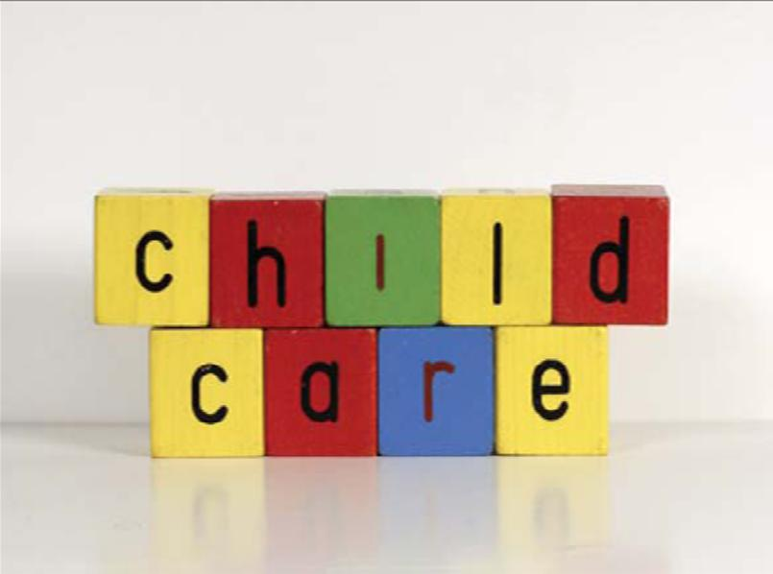

We know childcare is important to many families. While we do not advocate for, advertise for or promote any of the following centres, below is contact information to assist you in your search for care in the Whyte Ridge School community. The first link is to the Province’s Childcare Registry and is an excellent place to start your search.
http://www.gov.mb.ca/fs/childcare/index.html
http://www.ywinnipeg.ca/program/whyte-ridge-kindergarten/
http://www.ywinnipeg.ca/program/whyte-ridge-school-age-6-12-yrs/
https://direct3.gov.mb.ca/daycare/fs/fs.nsf/0/379195b72e26aaa486257a83006220a3?opendocument&Lang=1
Brightling Academy - Inspire Early. Imagine Always.
Advantage Child Care Academy
https://www.trpacademy.com/

